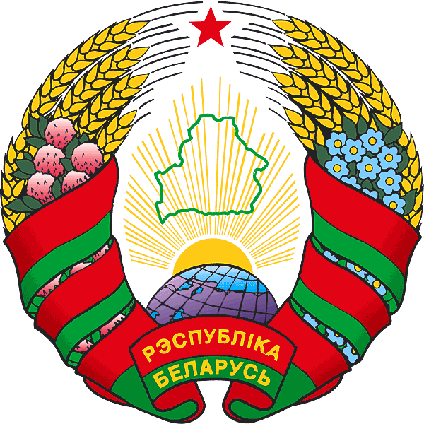
BELARUS

UNITED NATIONS GENERAL ASSEMBLY
71st session
Eighth CTBT Ministerial Meeting
“CTBT@20: Time to Finish What We Started”
New York, September 21, 2016

Statement
by His Excellency Vladimir Makei
Minister of Foreign Affairs
of the Republic of Belarus

Less than a month ago we commemorated the International Day against Nuclear Tests. The support expressed to the vision of the world free from nuclear testing and from nuclear weapons was overwhelming. To me, the most difficult puzzle is why this vast support to Comprehensive Nuclear-Test-Ban Treaty cannot help us finish what we started 20 years ago.
One cannot complain about lack of results, though. The number of states that signed and/or ratified the Treaty is impressive. We have a Preparatory Commission that is ready to be transformed into a full-fledged Organisation once it is needed. And we have highly professional Provisional Technical Secretariat to support the current activities. Over the years, the PTS has achieved extraordinary results in establishing the state-of-the-art global monitoring system, international data centre and in preparing for the on-site verification regime while also having the technology available for civil and scientific purposes.
We have everything ready for the moment when nuclear testing becomes officially outlawed. There are just a couple of things missing: political will, highest degree of responsibility and courage in order to change the existing antagonistic system of coordinates.
With deep concern Belarus has learned the latest news from the Korean Peninsula about another nuclear test conducted by DPRK. Such actions pose threat to the security and stability not only in the North-East Asia, but all around the world. Sustainable peace and stability can only be achieved through dialogue and mutual respect.
I truly believe that action in the field of nuclear disarmament is possible. The example of Belarus, who 20 years ago, at the time when CTBT was opened for signature, unconditionally renounced the possession of nuclear weapons, proves it. I can assure you that Belarus will remain a consistent adherent to and participant in the processes of nuclear disarmament and nonproliferation. This is our conscious contribution to fostering political will of the countries whose ratification is still missing and creating more suitable environment for the Treaty’s entry into force.

